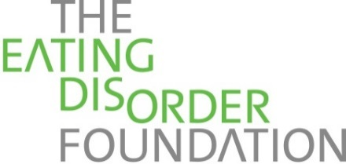
For Staff Use Only:
Group______________________
eTap #______________________
Follow up ___________________
Reminder ___________________
1901 E. 20th Ave.
Denver, CO 80205
(v) 303.322.3373 (f) 303.322.3364
(e) info@eatingdisorderfoundation.org
www.eatingdisorderfoundation.org

*** Please complete all of the fields below. We collect this information in order to provide the best support possible and to ensure your safety and well-being.
Teen Name: _______________________________ Age: __ Birthday: __________
Guardian Name(s):_________________________________________________
Address: ___________________________________________________
City: ____________________ State: ___ Zip: ____
Phone: _______________ Email Address: _________________________
May we leave voicemails if we contact you by phone? Yes No
How did you hear about EDF/A Place of Our Own? ________________________
Emergency Contact: ____________________Relationship: _____________
Contact’s Phone: ___________

Eating Disorder Foundation - Acknowledgment of Confidentiality
The Eating Disorder Foundation provides support; (EDF) is a non-treatment entity. Your recovery process might include the services of treatment professionals external to The Eating Disorder Foundation. Confidentiality is very important to creating a safe and supportive environment at EDF. We ask that our members, staff, and volunteers respect and maintain everyone’s right to confidentiality. If you are participating in a group at EDF, please agree to adhere to the following rules:
- I agree to respect and maintain the confidentiality of all EDF participants
- I agree not to identity other EDF participants to individuals outside of the group or the mentorship program without their consent
- I agree that what is discussed or explored in the EDF group must remain in the group.
Please be aware that we enlist the help of mental health professionals who are legally required to release information in the following situations:
- If there is reason to believe that a child, elderly person, or person with a disability is being abused or that abuse has occurred.
- When danger to self or others (such as a threat or serious bodily harm) requires disclosure.
- In the event of a medical emergency.
- Upon receipt of a court order.
- Or as otherwise required by state law.

By signing below, I ____________________, acknowledge that EDF exists solely to provide support, and not to fulfill the role of treatment and/or treatment professionals. I agree to respect and maintain the confidentiality of all EDF members and to not identify other members outside of A Place of Our Own without their consent. I understand that mental health professionals may need to contact others on a need to know basis without my consent in the event that an exception to confidentiality occurs.

____ __________________________________________ ________________
Signature Date
If under 18 years of age, please also have a parent or legal guardian sign:
Signature______________________ ___ _____ __ (Print) __________________________ Date ___________

